**REST - Get country based on country code**

**Objective:**

Create a REST endpoint that returns a country object based on a **case-insensitive** country code read from country.xml.

**URL Format:**

GET [http://localhost:8084/countries/{code}](http://localhost:8084/countries/%7bcode%7d)

**Example Request:**

GET http://localhost:8084/countries/in

**Expected JSON Response:**

**json**

{

"code": "IN",

"name": "India"

}

**Files Overview:**

**Country.java:** package com.cognizant.spring_learn;

import org.slf4j.Logger;

import org.slf4j.LoggerFactory;

public class Country {

private static final Logger *LOGGER* = LoggerFactory.getLogger(Country.class);

private String code;

private String name;

public Country() {

*LOGGER*.debug("Inside Country Constructor.");

}

public String getCode() {

*LOGGER*.debug("Inside getCode()");

return code;

}

public void setCode(String code) {

*LOGGER*.debug("Inside setCode()");

this.code = code;

}

public String getName() {

*LOGGER*.debug("Inside getName()");

return name;

}

public void setName(String name) {

*LOGGER*.debug("Inside setName()");

this.name = name;

}

*@Override*

public String toString() {

return "Country [code=" + code + ", name=" + name + "]";

}

}

**country.xml**

<bean id="countryList" class="java.util.ArrayList">

<constructor-arg>

<list>

<ref bean="country"/>

</list>

</constructor-arg>

</bean>

**CountryService.java**

Reads the country list from country.xml and performs a case-insensitive lookup:

public Country getCountry(String code) {

ClassPathXmlApplicationContext context = new ClassPathXmlApplicationContext("country.xml");

List<Country> countries = context.getBean("countryList", List.class);

context.close();

return countries.stream()

.filter(c -> c.getCode().equalsIgnoreCase(code))

.findFirst()

.orElse(null);

}

**CountryController.java**

@GetMapping("/countries/{code}")

public Country getCountry(@PathVariable String code) {

return countryService.getCountry(code);

}

**SpringLearnApplication.java**

Standard Spring Boot main class:

@SpringBootApplication

public class SpringLearnApplication {

public static void main(String[] args) {

SpringApplication.run(SpringLearnApplication.class, args);

}

}

**What to Test:**

curl http://localhost:8084/countries/IN

curl http://localhost:8084/countries/in

curl http://localhost:8084/countries/In

**Browser Output:**

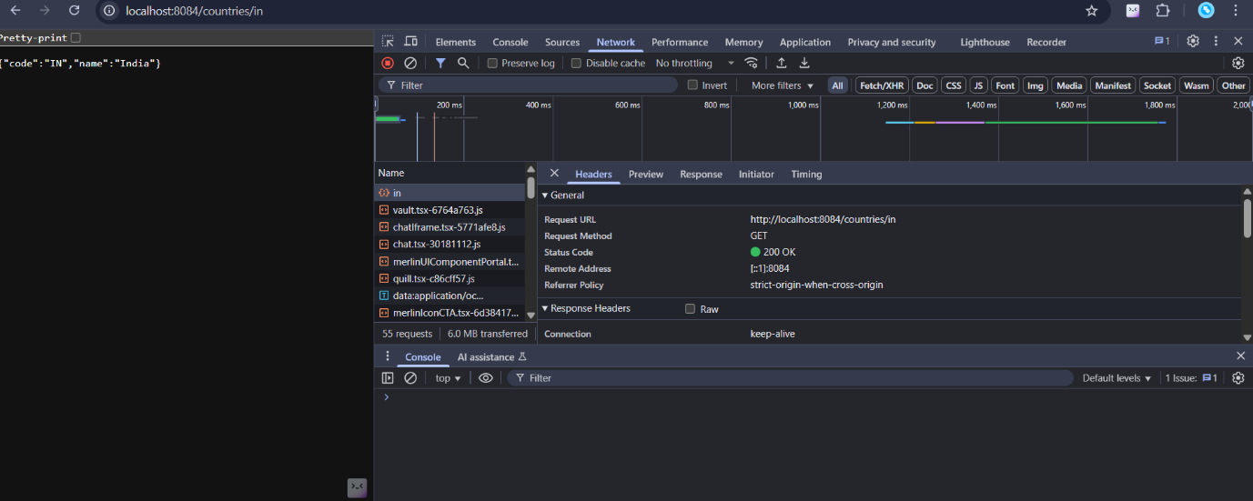

**Postman Output:**

